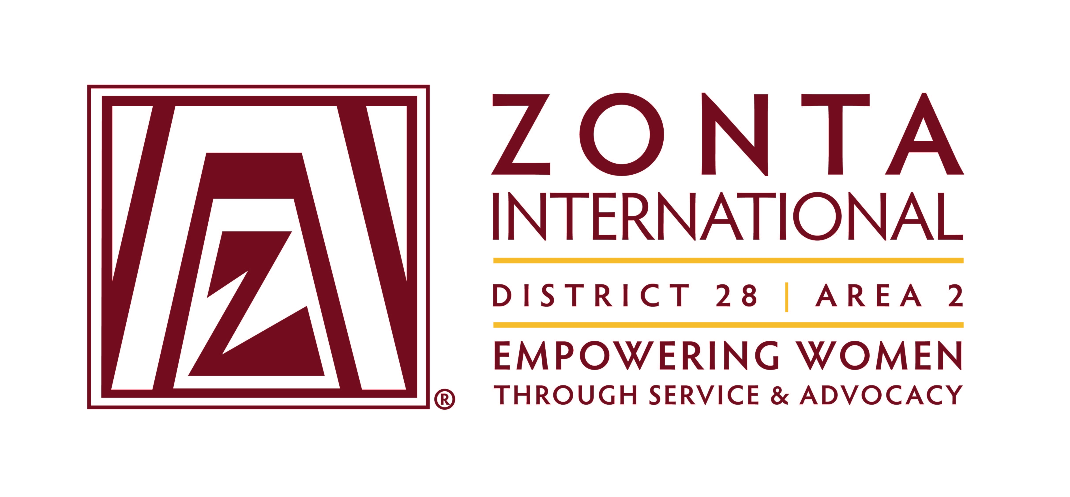

3rd Zonta Alumnae Seminar
March 27th / 28th, 2020
Frankfurt am Main

“Great Girls meet Great Women”

Agenda

Friday March 27th, 2020

3:30 pm guided tour “Air Traffic Control” in Langen (only for Alumnae)

6:30 – 9:00 pm Get-Together
Dinner/Buffet at Spenerhaus Speisesaal

Saturday March 28th, 2020

8:30 am Registration at Spenerhaus/ Forum im Dominikanerkloster

9:00 am Zonta Seminar at Spenerhaus (Forum)
Welcome by AD Fiona Ruff and Governor Fernanda Gallo-Freschi

9:15 am Teambuilding – Body Percussion with Nathalia Grotenhuis

10:00 am Keynote by Stephanie Renda
Manager Promerit AG, HR Consulting for Digital Transformation/ active in the National Association of German Startups / member of the “Beirat Junge Digitale Wirtschaft beim Bundesministerium für Wirtschaft und Energie”

“Female Empowerment – Finding Happiness”

11:20 am E-Clubs and Golden Z Clubs
Challenges and Chances of an e-Club / Golden Z Club - How to interact
with Zonta Clubs

Members of the e-Club Italy and Golden Z Club Main Taunus
11:50 Picture

12:00 pm Lunch

1:00 pm Teambuilding – Body Percussion with Nathalia Grotenhuis

1:45 pm World Café
“How to strengthen the attractiveness of Zonta for young women”
2:45 pm Summary of the World Café

3:00 pm closing

3:30 pm common activity in Frankfurt (details will follow)
optional for Alumnae and Zontians not joining the area A02 conference (estimated duration 2-2.5h)

The seminar will be held in English.

